|  |  |  |
| --- | --- | --- |
| **Philadelphia Federation of Teachers Health & Welfare Fund & Union** | **Evaluation Requested By**: PFT H&W Fund & Union **Page 1 of** | |
| **Date Inspected**: 3/18/2014  **Initial Inspection?** **☐**  **Follow-Up Inspection?** ☑ | **Inspected by:** Jerry Roseman MSc. I.H.  **Others Present? N**  **Name[s]:** |
| **IEQ Evaluation & Inspection Summary Report – Bryant E.S.** | **Date Report Issued**: 03-19-14  **Report Provided To:** Arthur Steinberg, PFTH&W Fund | Photos Attached**: ☑**  Sketches Attached: **☐** |
| **Building Name:** Bryant E.S. **Building Address:** 60th & Cedar Ave **Phone #:**  **Main Contact[s]:** Ms. Gaddy, Principal; Mr. Mack, Building Engineer & Ms. Curry, PFT Building Representative | | |
| **Inspection Overview:** Our 3/18/14 evaluation was initiated at the direction and request of the PFTH&WF/U & conducted as a follow-up and status update related to assessing the remediation of major long-term deficiencies in both interior and exterior building conditions that had resulted in significant water/moisture intrusion, with associated mold growth and related health impacts to occupants. Previous inspections were conducted on 12/2 [without OEMS representatives present] and then again on 12/3 with Brian Joseph [KEM-OEMS] present. OEMS conducted subsequent evaluations at this location [although no notice was provided to PFTH&WF/U and so it is impossible to determine how many and/or what dates] with eleven [11] significant deficiencies documented throughout the building [with a “report” date of 12/19/13 as included on the 3/14/14 IEQ Dashboard].    [1] The majority of the deficient building conditions previously identified at Bryant E.S. and reportedly present for years, are still present and had **not** been fully and/or properly addressed as of the date of this inspection;  [2] Normally occupied areas throughout the school were found to have varying degrees of damaged lead-containing [presumed] paint and plaster with dust on classroom surfaces [photos attached below] – **all painted surfaces in the schools are presumed [by OEMS] to contain lead paint and are to be treated as such according to OEMS**;  [3] Water stained and damaged ceiling tiles and other building materials were present in normally occupied areas of the building including in both the “original” structure and in the addition [containing the IMC and cafeteria] – this is an ongoing and repetitive condition.  [4] The 2nd floor Boys Bathroom [across from rm 206] had extensively and significantly damaged paint [lead-containing] and plaster as well as significantly damaged and exposed fiberglass insulation [a respiratory hazard]. Additionally, steam heating pipes were uninsulated in this area and throughout classrooms **presenting a serious burn hazard to children**;  [5] Several classrooms and other normally occupied spaces had dust and debris [including from lead-containing paint] on floors, window sills and other horizontal surfaces. This dust and debris is “fallout” from the damaged walls and ceilings and **presents potential respiratory hazards to building occupants**;  [6] The IMC ceiling was significantly damaged by water intrusion and ceiling leaks – large trashcans, filled with newspaper and stagnant, standing water were observed in the IMC;  [7] The Bryant E.S. new addition was excessively cold at the time of our inspection with measured temperatures ranging from 62 deg. F – 66 deg. F in the IMC and other areas new addition areas.  **The observational inspection conducted on 3/18/14 was not intended to be fully comprehensive in scope or extent; however, at least eighteen [18] individual areas plus hallways were assessed during the evaluation. Inspection of the building exterior and interior spaces as well as discussions with school staff confirmed that significantly deficient building exterior conditions have not yet been addressed resulting in ongoing and continuing moisture, dampness and water intrusion from roof leaks [multiple] and major brick pointing/building envelope failures.** | | |
| ***\*\*\* The table below contains issues not previously mentioned [it is NOT a comprehensive listing] – In order to develop a complete list of all deficiencies, it is necessary to include observed and documented damage and notes and corrective actions as reported on OEMS’s IEQ Dashboard[s] in addition to other documents that should be available from, and in the possession of, the PSD [including Maintenance work orders, results of monthly FAC surveys, and other IEQ-related inspection activities as well as previously reported issues by the PFTH&WF/U] in October and December of 2013\*\*\****   |  |  |  | | --- | --- | --- | | **Room –Area Inspected** | **Relevant Observations, Findings & Measurements** | **Comments-Recommendations-Informational Request** | | IMC | Four [4] buckets/large trash cans to catch water from a reportedly leaking roof were filled with newspaper and stagnant water and were present in the IMC | 1. Assess & evaluate source/root causes of ongoing leaks and immediately make repairs as necessary;  2. Redo repair to newly damaged ceiling materials | | New Wing - Addition | Thermal Control Deficiency – Area was extremely cold with measured temperatures approximately 62 – 66 degrees F | 1. Assess & evaluate thermal control issues and repair; | | 2nd Fl. Boys Bathroom  and  Girls Bathroom | Boys Bathroom - Significantly damaged lead-containing paint and plaster in addition to damaged and/or missing fiberglass insulation – **Serious Burn Hazard Risk**  Girls Bathroom – Significantly damaged lead-containing paint and plaster | 1. Scrape, patch, repair and paint damaged paint and plaster in both bathrooms;  2. Repair/replace damaged fiberglass insulation – boys bathroom  3. Immediately address burn hazard from accessible heating piping – boys bathroom | | Faculty Lounge Bathroom | Badly damaged paint and plaster was observed & documented in this area | 1.Assess & evaluate the source of moisture and dampness and scrape, patch, repair and paint damaged paint and plaster necessary following lead-safe precautions and procedures;  2. Repair damage to ceiling materials | | Multiple Classroom Areas - Throughout | [a] Un-insulated, accessible and exposed steam heating piping was observed in a number of classroom areas;  [b] Dust and debris [lead-containing] was observed on window ledges and other surfaces in classrooms associated with damaged paint and plaster | 1. Continue ongoing patch/repair & “finishing” work;  2. Provide schedules, work lists and summaries for accountability, communication & coordination purposes;  3. Provide additional cleaning personnel to effectively control dust and debris from remediation activities | | Moisture, Water Intrusion, Dampness – Root Cause | [a] Roof Leaks have been identified in more than one area;  [b] Major and long-standing issues with masonry, brick pointing and windows resulting in moisture, water intrusion and dampness have been identified | 1. Evaluate exterior conditions as recommended previously and provide summary report;  2. Develop a work plan & schedule to address exterior damage conditions in order to minimize and stabilize impacts associated with ongoing water intrusion;  3. Provide comprehensive information to occupants, stakeholders & others about problem and work scope and schedule  4. Replace damaged/stained ceiling tiles and other building materials as necessary | | | |

**Discussion & Recommendations**

**[1] Evaluation Overview –** This evaluation again documented ongoing, repetitive and severely deficient building conditions in numerous school areas. Reports and information have been available to/from OEMS, FMS and CPO for several years, and from multiple sources [Maintenance Dept. Work Order system data, FAC monthly inspections, assessments/evaluations by FMS managers and supervisory personnel, OEMS inspection and evaluation data as included on IEQ Dashboards, NIOSH-supported DMAT surveys & other IEQ/Health and Safety assessments], as well as from information provided by the PFTH&WF/U.

**A critical review of all existing relevant data and information should be conducted to in order to develop strategies and priorities for a comprehensive solution to the IEQ and related problems at this school.**

**[2] Roof Leaks** – Ongoing and/or repeated roof leaks have been documented as occurring in several building areas [by OEMS at least as of 12/19/13] including in areas that had been recently “repaired” [eg. IMC, New Addition Stairwell & 3rd Floor Hallway – all per OEMS IEQ Dashboard].

**This “root cause” issue must be comprehensively identified and systematically addressed to ensure cost effective and permanent remediation**.

Our previous recommendation, *“Considering the extent, necessity and cost of interior stabilization and repair work, a comprehensive and detailed evaluation of the roof condition and repair needs should be immediately performed*” is again restated here. In addition, it should be highlighted that in our judgment the current PSD remediation approaches at Bryant not only continue to place occupant health and safety at increased risk but also compromises educational programming [the IMC is, and has been, substantially unusable because of the leak and thermal control issues] and fiscal sustainability [as “repaired” materials become re-damaged and roof and other repair work are not successfully fully executed]

**[3] Steam Heating-Burn Risk –** Using steam to produce radiant heat involves supply piping [feeding radiators] that is excessively hot. Unless hot steam pipes are made inaccessible to contact from elementary school students, or are properly insulated, they present a burn hazard as has been documented here.

**Accordingly it is recommended that immediate steps be taken to insulate and/or cover/protect and make sufficiently inaccessible to students all heating pipes at the school**

**[4] Exterior Repair [Masonry and other Building Envelope Issues] –** Because of the scale, scope and long-term nature of the exterior problems at Bryant, and the many-year knowledge about these issues by SD FMS & CPO managers, **an effective interim plan to stabilize the exterior and to repair all deteriorated interior surfaces is immediately needed.**

**Additionally, and as recommended on the IEQ Dashboard, “The brick pointing repairs for this location should be scheduled.”**

We agree with this recommendation – now assigned to the CPO – but **we would recommend that this work be immediately undertaken**. As pointed out before, the need for brick repointing has been known, recognized and acknowledged for many years and, for a variety of reasons, including a lack of intra- and inter-departmental coordination and cooperation, as well as changing decisions and shifting priorities by PSD management, this long-needed work has not been scheduled.

**[5] Interior Paint [Lead-Containing] & Plaster Remediation** – As on previous evaluations over the past five [5] months, extensive and continuing damage to lead-based paint and plaster was documented in many building areas. The damage is due to dampness, moisture and water intrusion from deficiencies in the exterior masonry, and from roof leaks in addition to other possible root causes/sources. It is also noted that these conditions have existed for many years. Evidence for the long-term presence of these problems includes:

[a] Consistent reports from building occupants about the multi-year existence of these conditions;

[b] A 2011 OEMS inspection [details were provided in our previous reports] conducted as part of a what was a joint and collaborative [PSD & PFTH&WF/U] “proactive and comprehensive” programmatic effort to conduct IEQ and related building condition evaluation in all Philadelphia schools [the program was halted by the PSD-OEMS more than 9 months ago]; and

[c] The consequential nature of the type of damage observed – interior damage of the scale, scope and extent of that documented at Bryant is the result of long-term and ongoing water intrusion, dampness and moisture and a lack of effective maintenance and/or capital response.

Many leading authorities, researchers and governmental agencies, including the Institute of Medicine [IOM] of the U.S.. National Acadamies, the World Health Organization [WHO], CDC-NIOSH, OSHA, EPA, the American Society of Heating Refrigeration and Air Conditioning Engineers [ASHRAE], have all concluded that **dampness, moisture, water intrusion and resulting damage to building materials [or the type documented at Bryant] pose serious and significant respiratory disease hazards, including asthma to building occupants**

**Accordingly it is our recommendation that interior damage as noted on multiple reports be immediately and comprehensively addressed to prevent further risks to building occupant health and safety**

**[6] General Cleaning Issues –** Due to the extent of the damaged/deteriorated building materials throughout the school, and associated with whatever paint and plaster remediation work is being conducted, significant dust and debris, including that of lead-containing paint is on classroom and other surfaces.

**Especially given the presence of lead paint [and dust] and plaster dust – asthma triggers and respiratory irritants – the development and implementation of a cleaning plan to include wet-wiping/mopping, HEPA-vacuuming and related “lead-safe” and dust minimization cleaning approaches are recommended to begin immediately**;

**[7] IEQ Dashboard Issues -** On the IEQ Dashboard, dated 11/22/13, corrective action items were listed for this school; 18 of these items were listed as “closed” and completed by the Maintenance Dept. including the evaluation and repair of the roof. However, inspection activities in December of 2013, resulted in the conclusion that these issues were, in fact, still open and, as of the 3/18/14 inspection, the same problems continue to persist.

**We recommend that specific time frames, associated with corrective actions, be included on the IEQ Dashboard for purposes of accountability, communication and the implementation of effective remediation.**

**We also recommend that an effective “project management” oversight approach be developed and implemented sufficient for ensuring that recommended actions are actually conducted in a competent and timely manner – that system does NOT currently exist**

**[8] Information Sharing, Collaboration and Coordination**

A continuing issue and problem with the approach of the PSD is the lack of effective information sharing, transparency, collaboration and coordination at many levels:

[a] The processes and mechanisms for informing building occupants including administrators of schools in which FMS, CPO and/or OEMS work is being planned, conducted and implemented, and the status and timing of that work is very poorly communicated and tracked;

[b] Intra- and Inter-Departmental coordination [between FMS, CPO and other departments and offices] is limited and is often a contributing factor responsible for the slowness and inefficiency of repair and remediation efforts conducted. This deficiency also compromises both fiscally sustainable remediation as well as negatively impacting on educational/academic programming;

[c] There is too little transparency, data sharing, and collaboration between stakeholders and those directly impacted by the deficient building conditions, and PSD managers and departments; and

[d] There is a significant lack of accountability and sustainable documentation available, especially related to root cause analysis of long-term building problems and about the timing, scope and implementation of remediation efforts – this has been acknowledged and recognized by PSD managers.

**Given the above we recommend:**

* **Immediately beginning a formal process with the PSD, and involving stakeholders and those directly impacted by the conditions described in this report, about the implementation of a comprehensive IEQ, building condition and remediation program that includes discussions about prioritization, scope, practical, and accountable remediation strategies to effectively address deficient and dangerous building conditions;**
* **The implementation of a fully transparent and collaborative approach to the sharing of data and information at least as robust as, and consistent with, the City of Philadelphia’s Open Data & Social Media Policy;**
* **The return to the collaborative and joint evaluation and reporting “program” in place prior to November of 2013, between the PSD and the PFTH&WF/U [and as previously detailed and provided in written form with PSD management]; and**
* **The sharing of all reports, summaries and information related to IEQ-building condition related evaluation remediation, including but not limited to asbestos, lead and construction issues with the PFT H&W Fund/Union representatives & building occupants in a timely and ongoing manner;**

**PHOTO LOG -** **Selected & Representative** **Photos [3/18/14 Inspection]**

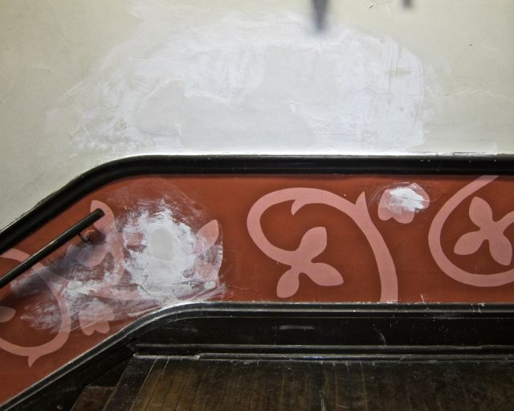

**Bryant E.S. – 3/18/14 – Typical “stabilization” action – Paint Scraping and Patching**

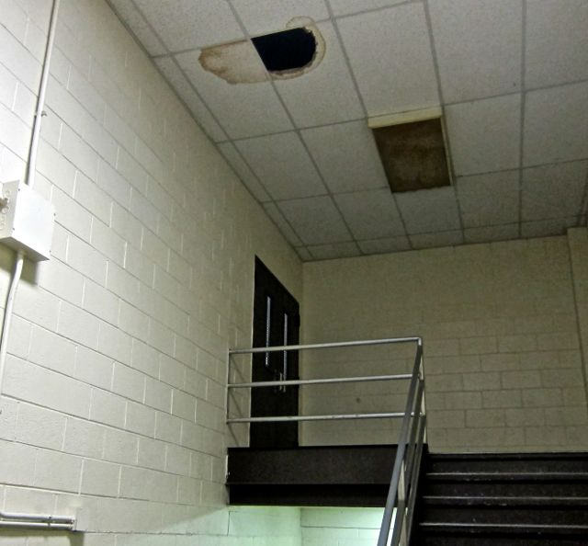

**Bryant E.S. – 3/18/14 – Stairwell to Addition – Ceiling/Roof Leak – Damaged Tile – still remaining**

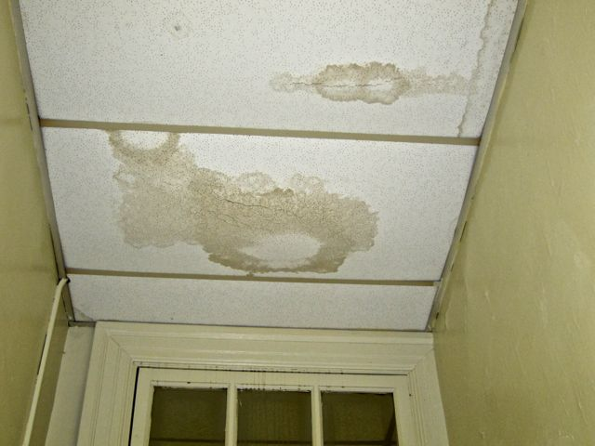

**Bryant E.S. – 3/18/14 – Classroom 208 – Coat Closet**

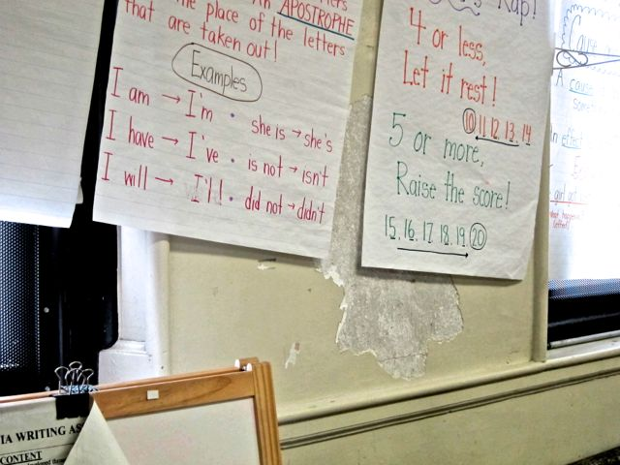

**Bryant E.S. – 3/18/14 – Classroom 208 – Wall Condition**

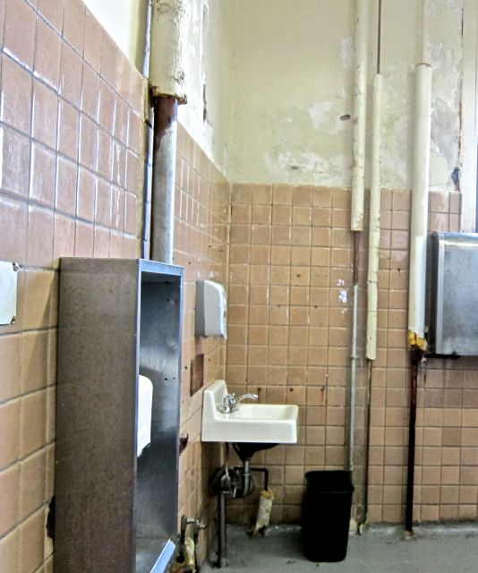

**Bryant E.S. – 3/18/14 – Boys Bathroom – 2nd Floor – Significant damage to lead paint and plaster & Fiberglass Insulation – Burn Hazard from uninsulated heating pipe [toward right side]**

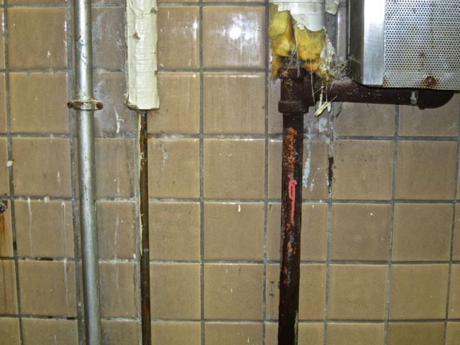

**Bryant E.S. – 3/18/14 – Boys Bathroom – 2nd Floor – Close up of damage to fiberglass insulation and exposure to hot pipe**

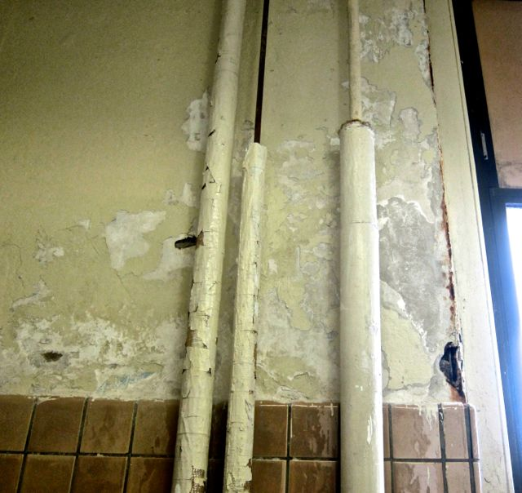

**Bryant E.S. – 3/18/14 – Boys Bathroom – 2nd Floor – Close up of damage to lead paint and plaster walls**

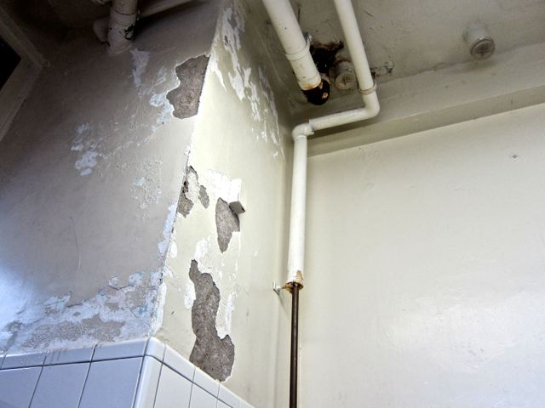

**Bryant E.S. – 3/18/14 – Boys Bathroom – 2nd Floor – Close up of damage to lead paint and plaster walls**

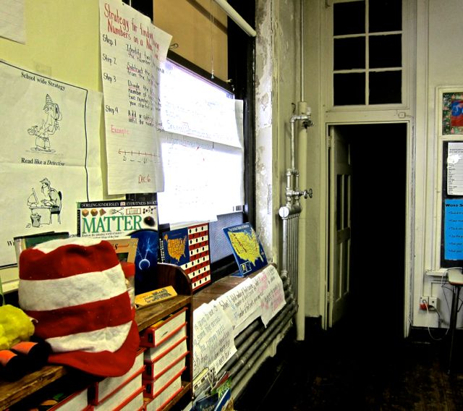

**Bryant E.S. – 3/18/14 – Room 214 – Typical Condition – Damage to Lead Paint and Plaster**

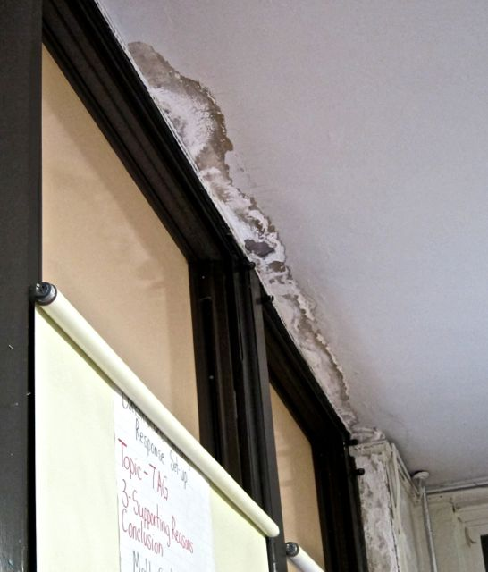

**Bryant E.S. – 3/18/14 – Room 214 – Close-Up of Ceiling Damage**

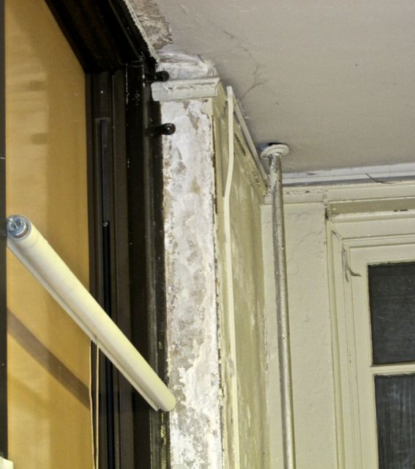

**Bryant E.S. – 3/18/14 – Room 214 – Close-Up of Wall Damage**

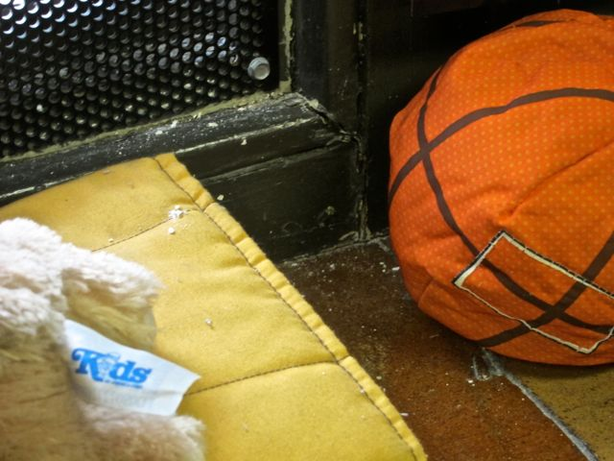

**Bryant E.S. – 3/18/14 – Room 214 – Lead-based paint dust and plaster debris on classroom surfaces**

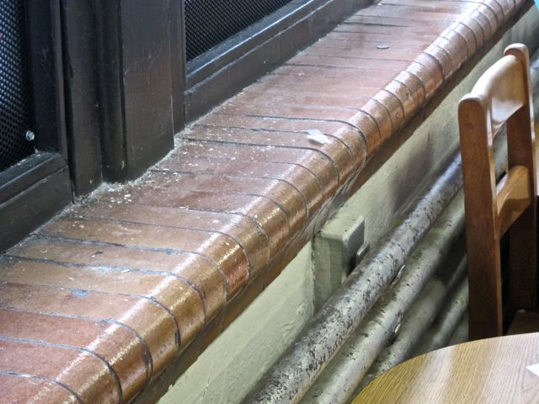

**Bryant E.S. – 3/18/14 – Room 212 – Lead-based paint dust and plaster debris on classroom surfaces**

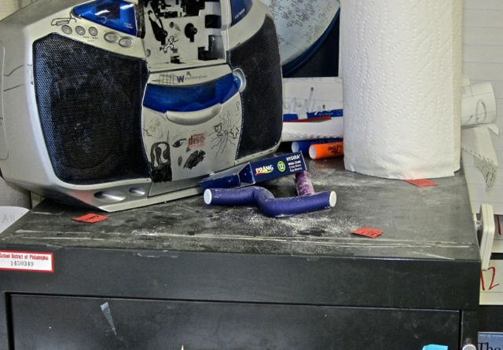

**Bryant E.S. – 3/18/14 – Room 210 – Lead-based paint dust and plaster debris on classroom surfaces**

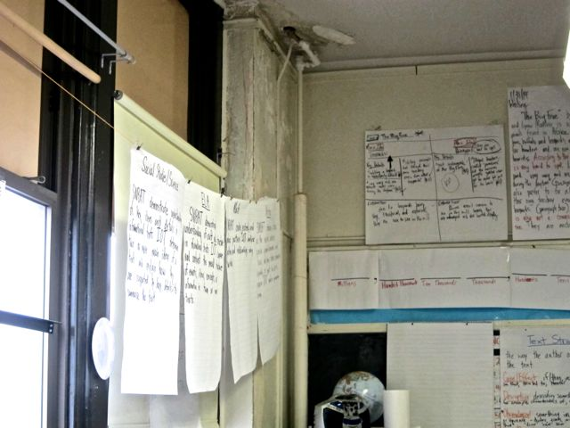

**Bryant E.S. – 3/18/14 – Room 210 – Damaged/Deteriorating lead-based paint dust and plaster**

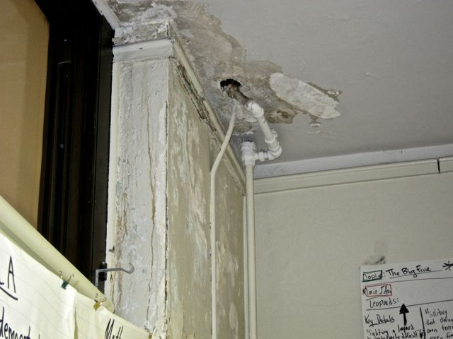

**Bryant E.S. – 3/18/14 – Room 210 – Close-Up of Damaged/Deteriorating lead-based paint dust and plaster**

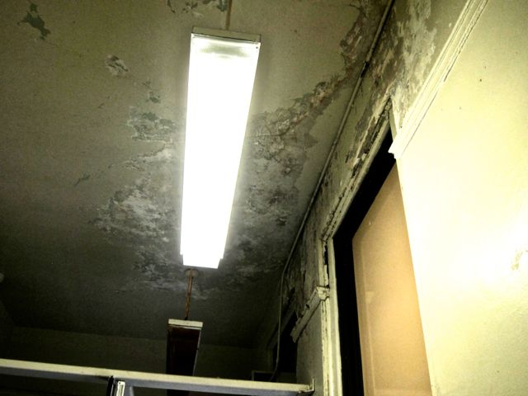

**Bryant E.S. – 3/18/14 – Girls Bathroom – Damaged & deteriorated lead-based paint and plaster**

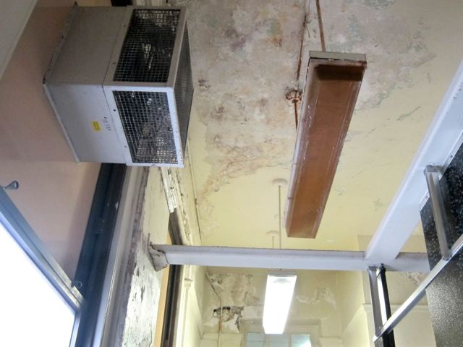

**Bryant E.S. – 3/18/14 – Girls Bathroom – Damaged & deteriorated lead-based paint and plaster – Close-Up**

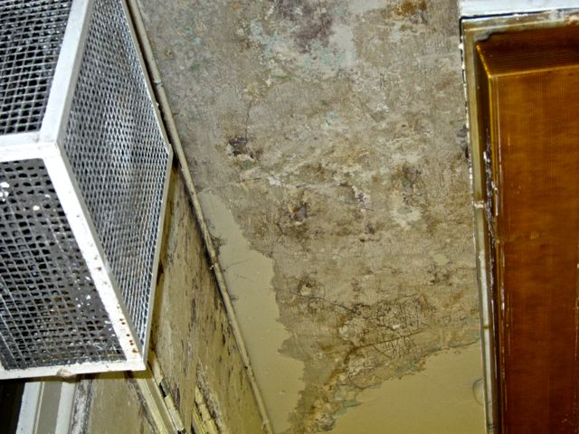

**Bryant E.S. – 3/18/14 – Girls Bathroom – Damaged & deteriorated lead-based paint and plaster – Close-Up**

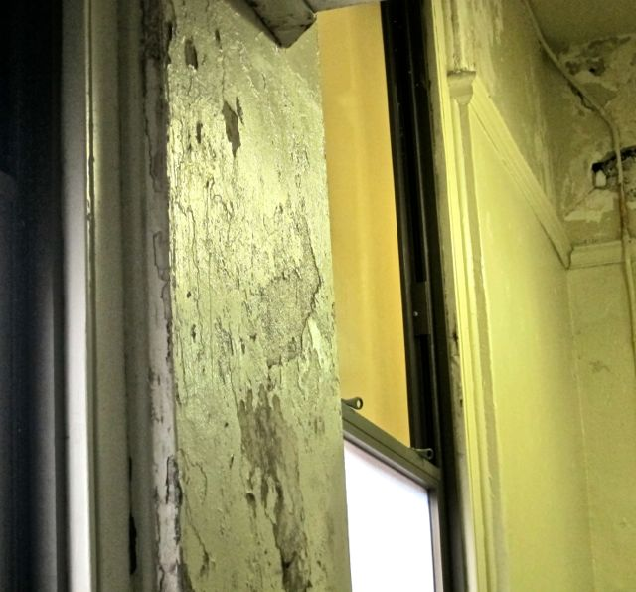

**Bryant E.S. – 3/18/14 – Girls Bathroom – Damaged & deteriorated lead-based paint and plaster – Close-Up**

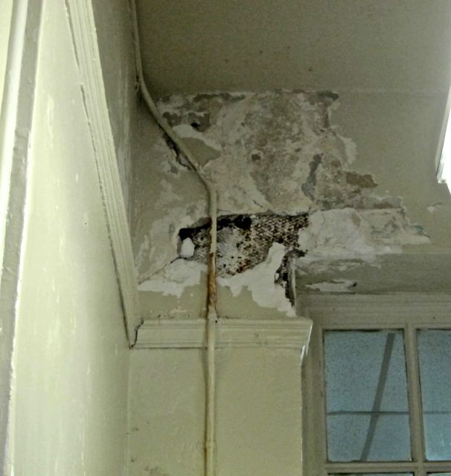

**Bryant E.S. – 3/18/14 – Girls Bathroom – Damaged & deteriorated lead-based paint and plaster – Close-Up**

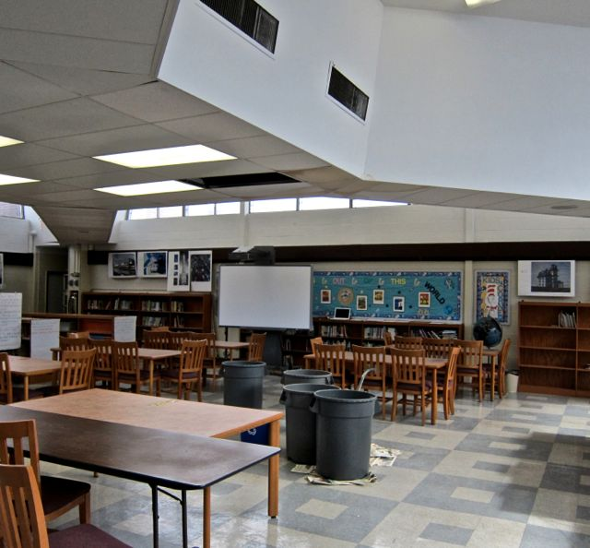

**Bryant E.S. – 3/18/14 – IMC – Water leak from Ceiling – 4 “catch buckets” in place**

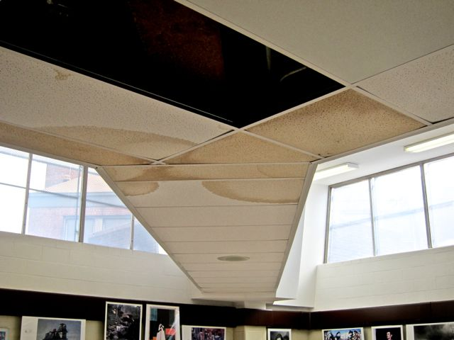

**Bryant E.S. – 3/18/14 – IMC – Water leak from Ceiling – Close-Up View**

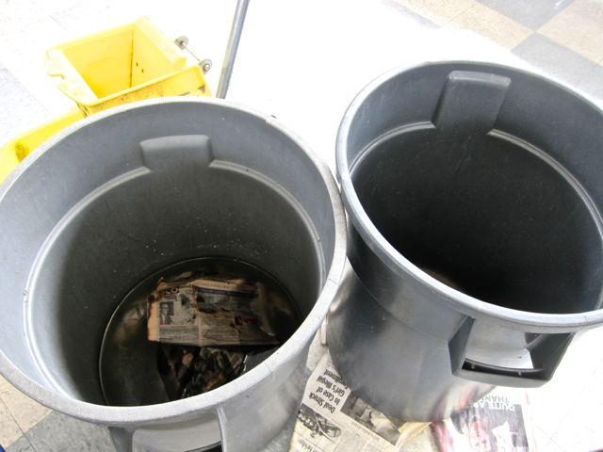

**Bryant E.S. – 3/18/14 – IMC – Water leak from Ceiling – Buckets used to “catch” water – still in area with stagnant water and newspapers**